

**Faculty of Computers and Information Cairo University**

**Advanced Software Engineering**

**Software design specification document 2020**

**Dedicated to Dr.Soha Makady**

**Project Team**

|  |  |  |  |
| --- | --- | --- | --- |
| **ID** | **Name** | **Email** | **Mobile** |
| 20180285 | Moaz Basheer Anwer | moazbasheer97@gmail.com | 01144564572 |
| 20180193 | Fady Emad | fadyemad14705@gmail.com | 01203732443 |
| 20180235 | Mohamed Mohsen Ahmed | mohamedmohsen46saeed@gmail.com | 01150762134 |
| 20180250 | Mahmoud Ashraf | ma5027300@gmail.com | 01102488789 |

**[TA : Mahmoud Hadad]**

**Contents**

Class diagram design 3

Sequence diagram design 4

Github repository link 10

# Class diagram design

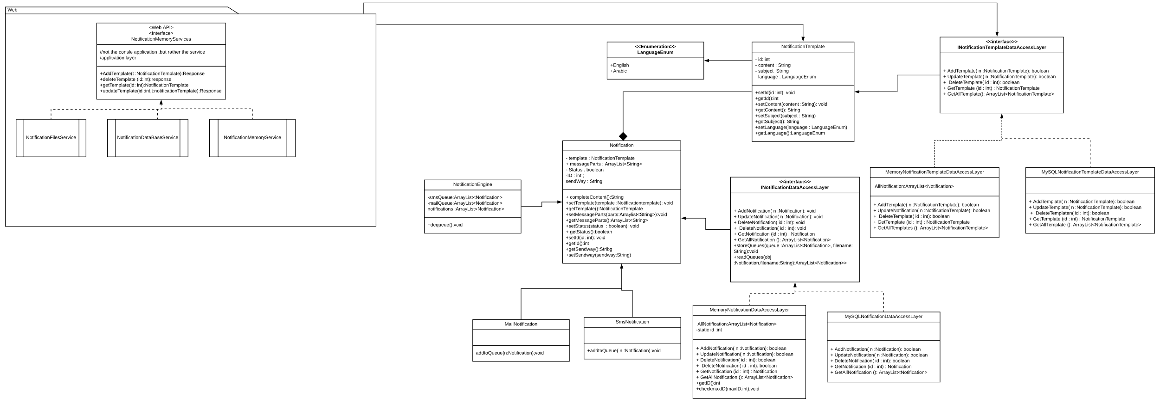

# Sequence diagram design

# Github repository link

https://github.com/dudo48/ASE-Project-Sprints